Software Design Specifications

[Airport Management System]

Version: [01.00]

Project Code | SE2004
Supervisor | Ms. Rubab
Co Supervisor | Imam Ali Mehdi
Project Team | Muhammad Abdul Hadi Hasan 24k3018  Usman Khan 24k3032  Aleem Abbas 24k3070
Submission Date | 02/05/2026

Document History

Version | Name of Person | Date | Description of change
0.1 | Abdul Hadi | 01/05/2026 | [Document Created]

Distribution List

Name | Role
Ms. Rubab | Supervisor
Imam Ali Mehdi | Co Supervisor

Document Sign-Off

Version | Sign-off Authority | Project Role | Signature | Sign-off Date
1.0 | Abdul Hadi | Documentation + Analyst |  | 01/05/2026
1.1 | Usman Khan | Refining + Backend design |  | 02/05/2026
1.2 | Aleem Abbas | Database design |  | 03/05/2026

Document Information

Category | Information
Customer | FAST-NU
Project | Airport Management System
Document | Software Design Specification
Document Version | 1.0
Status | Complete
Author(s) | Abdul Hadi, Usman Khan, Aleem Abbass
Approver(s)
Issue Date | 02/05/2026
Document Location | Karachi
Distribution | Advisor  Project Coordinator’s Office (through Advisor)

Definition of Terms, Acronyms and Abbreviations

Term | Description
AMS | Airport Management System

Table of Contents
1 Introduction 8
1.1 Purpose of Document 8
1.2 Intended Audience 8
1.3 Document Convention 8
1.4 Project Overview 8
1.5 Scope 8
2 Design Considerations 9
2.1 Assumptions and Dependencies 9
2.2 Risks and Volatile Areas 9
3 System Architecture 10
3.1 System Level Architecture 10
3.2 Software Architecture 10
4 Design Strategy 11
5 Detailed System Design 12
5.1 Database Design 12
5.1.1 ER Diagram 12
5.1.2 Data Dictionary 12
5.1.2.1 Data 1 12
5.1.2.2 Data 2 12
5.1.2.3 Data n 12
5.2 Application Design 14
5.2.1 Sequence Diagram 14
5.2.1.1 <Sequence Diagram 1> 14
5.2.1.2 <Sequence Diagram 2> 14
5.2.1.3 <Sequence Diagram n> 14
5.2.2 Activity Diagram 14
5.2.2.1 Customer can register himself 14
5.2.2.2 Admin can check customer records 14
5.2.2.3 Admin can add flights, airlines etc. 14
5.2.2.4 Customer can book flights _____________________________________________ 14
5.2.2.5 Customer can add baggage_____________________________________________14
5.2.3 State Chart Diagram________________________________________________________ 15
5.2.4 Class Diagram ____________________________________________________________ 15
5.2.5 Collaboration Diagram______________________________________________________ 15
6 References 15
7 Appendices 16

Introduction

Purpose of Document
The purpose of the current Software Design Specification (SDS) is to produce a detailed technical description of the Airport Management System (AMS). Specifically, it will serve to efficiently translate functional requirements into a complex architecture. While being an important source of detailed data for software developers and quality assurance engineers to be used when designing and testing the object-oriented logic of the AMS, the document is expected to facilitate decision-making regarding technical feasibility of the project on the part of its managers.

Intended Audience
Supervisor and Co-supervisor of project.

Document Convention
Calibri at 12 font size mostly.

Project Overview
The AMS is a software integration system specifically designed to automate crucial functions in an airport, including baggage handling, ticket management, and aircraft scheduling. The key emphasis of the design approach is on an architectural design that segregates the system into three distinct layers: the User Interface Layer, the Middle Tier, and the Data Access Layer. The design ensures that the system remains resilient and scalable enough to handle substantial amounts of passenger data.

Scope
The passenger experience, from profiling through passport verification all the way through ticketing up until the time when flights are recorded, is all encompassed in the system’s scope of work. Despite the plethora of features that can be found within the system, which includes features useful for airline registry and accounting, duty-free goods and real-time air traffic control information are specifically excluded from it. This is made possible by the limited scope of work of the system.

Design Considerations

Assumptions and Dependencies
The architecture of AMS assumes that the administrative users have at least a fundamental knowledge of airport operations and that the required infrastructure is always available. For secure transactions and verification of passenger documents in real time, the integration of external Payment Gateways and Regulatory Authority databases is important. Once such external factors are identified, it ensures that the system architecture incorporates any possible delays or connectivity requirements of the external APIs.

Risks and Volatile Areas
The threats that include the risks of security in data storage and the dynamic nature of rules and regulations in aviation need to be minimized through the system. This design emphasized the implementation of high-level encryptions when accessing the database since money transaction and passport data are considered as sensitive data. Moreover, the design has also made the system's business logic extremely flexible, allowing it to accommodate new rules without any changes to its structure because rules may change from time to time.

System Architecture

System Level Architecture
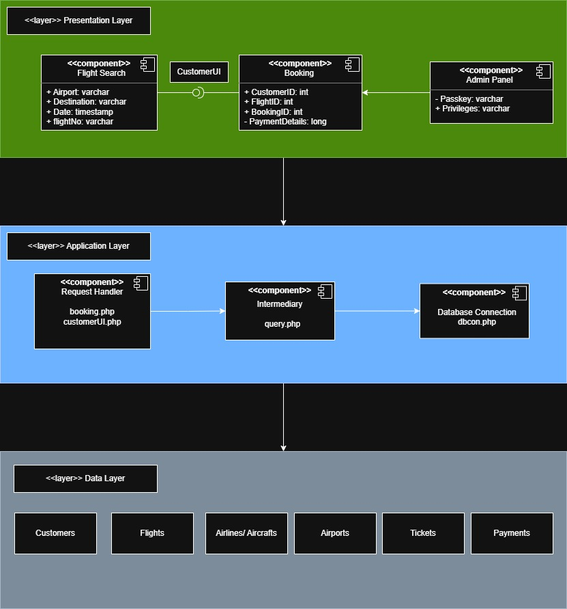

Software Architecture
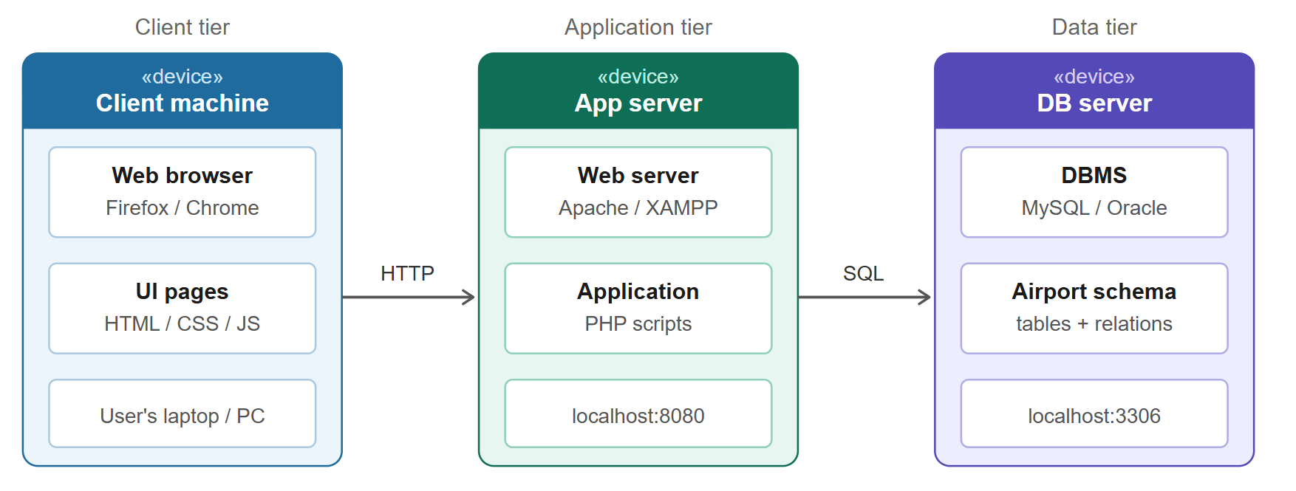

Design Strategy
The modular nature of the Airport Management System (AMS) ensures future scalability and enhancement of the system itself. The introduction of new aviation technology, such as biometric boarding, will not require complete reconstruction of the architectural design since the whole program will be split into separate modules such as Financial Module and Flight Operations Module. Because key components of the AMS, such as the third-party Payment Gateway integration and User Authentication module, will be abstracted as independent modules that can be reused in other logistics systems.
The design employs portals which are designed specifically to address unique needs with regards to user interface paradigms. Whereby airport staff and managers employ desktop-friendly dashboards with the ability to input large amounts of data while managing registries, on the other hand, clients interact using mobile-optimized booker portal. Relational database management is implemented to achieve strict ACID characteristics within the application design and development. It ensures the accuracy and coherence of important information including payments logs and ticket statuses among others.
To overcome the problems associated with high traffic scenarios, concurrency and synchronization methods are considered vital. The logic layer makes use of row level database locking while selecting seats for passengers so that there is no situation whereby different users simultaneously book the same seat. Furthermore, the system controls terminal transactions by means of concurrency states such that, for instance, the travel experience for one passenger will progress to the boarding stage provided that parallel transactions for security checks and luggage weight verification succeed.

Detailed System Design

Database Design

ER Diagram
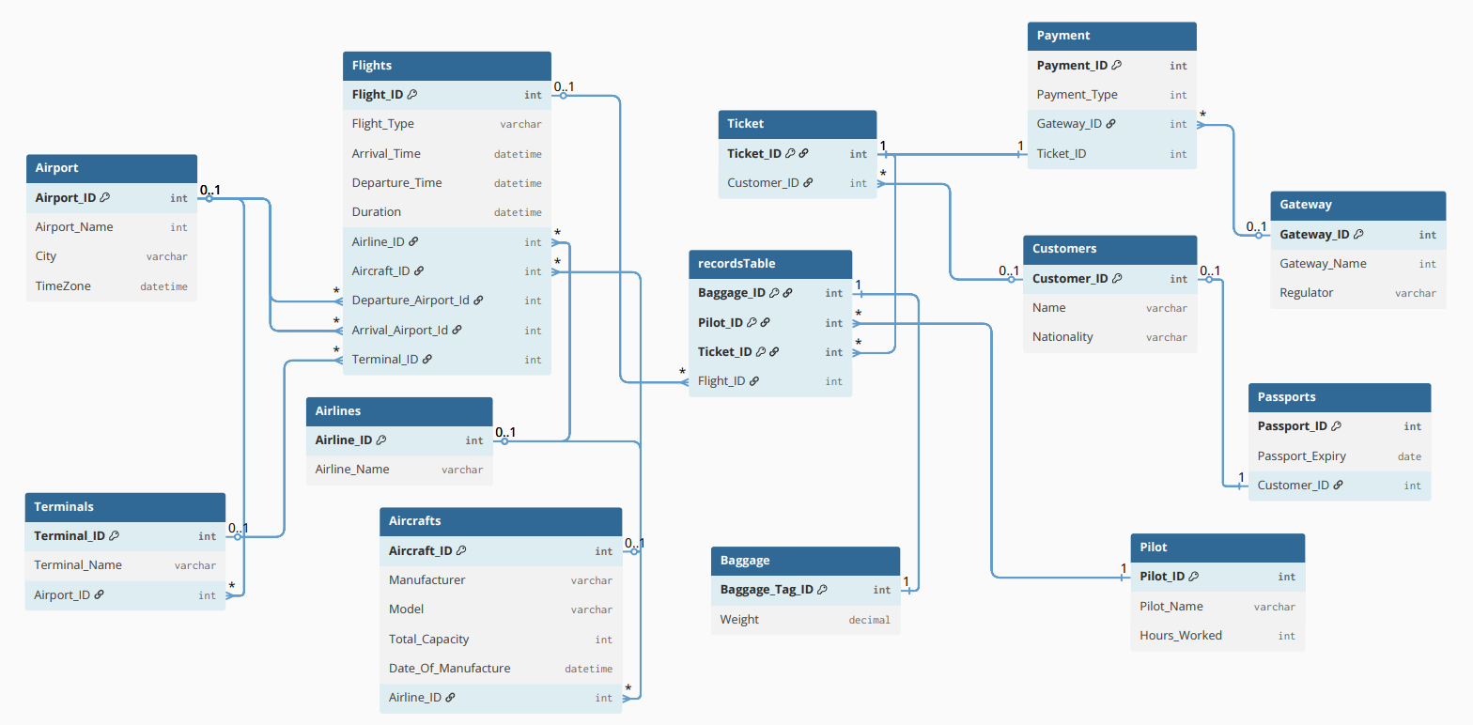
A total of 13 tables with multiplicites between them. Left side is flight centric and right side is customer centric.

Data Dictionary
[The convention recommended for writing the data dictionary is as follows.]

Data 1
[Description (Refer to Template on next page). ]

Data 2
[Description (Refer to Template on next page). ]
.
.

Data n
[Description (Refer to Template on next page). ]

< Data 1>
Name |  | Give primary name of the data or control item, the data store or an external entity.
Alias |  | Write other names used for the first entry.
Where-used/how-used |  | List all processes that use the data or control item and how it is used (e.g., input to process, output from the process, as a store, as n external entity)
Content description |  | Notation for representing content.
Column Name | Description |  | Type | Length | Null able | Default Value | Key Type
[Column1 Name] | [Description of the column] |  | [Type of column] | [Length of column] | [Is Column Null able] | [Default Value] | [If Primary Key than write PK, if Foreign Key then FK, if not a key leave it blank]
[Column2 Name] | [Description of the column] |  | [Type of column] | [Length of column] | [Is Column Null able] | [Default Value] | [If Primary Key than write PK, if Foreign Key then FK, if not a key leave it blank]

[Make similar tables for all the data items.

The notation to develop content description is given below:

Data construct | Notation | Meaning
 | = | is composed of
Sequence | + | And
Selection | [|] | either-or
Repetition | {}n | n repetitions of
 | ( ) | optional data
 | * … * | delimits comments
]

Application Design

Sequence Diagram

Customer registration and booking
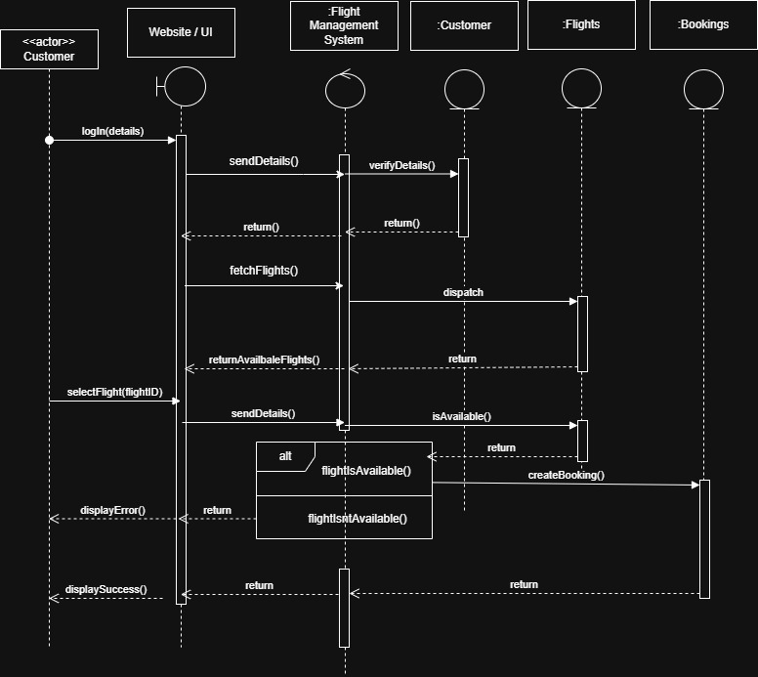

Admin privileges and flight creation
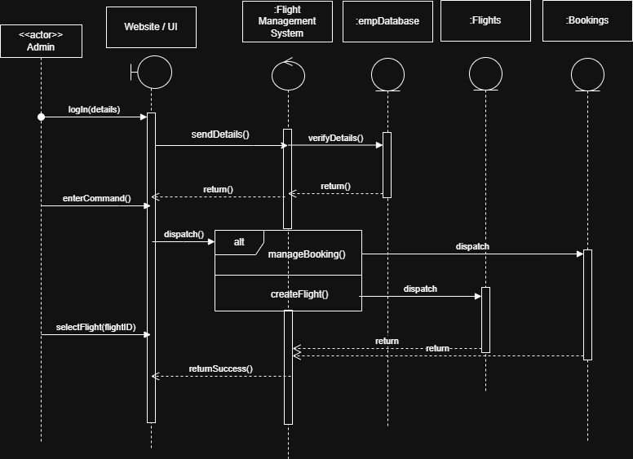

Activity Diagram

Customer can register himself
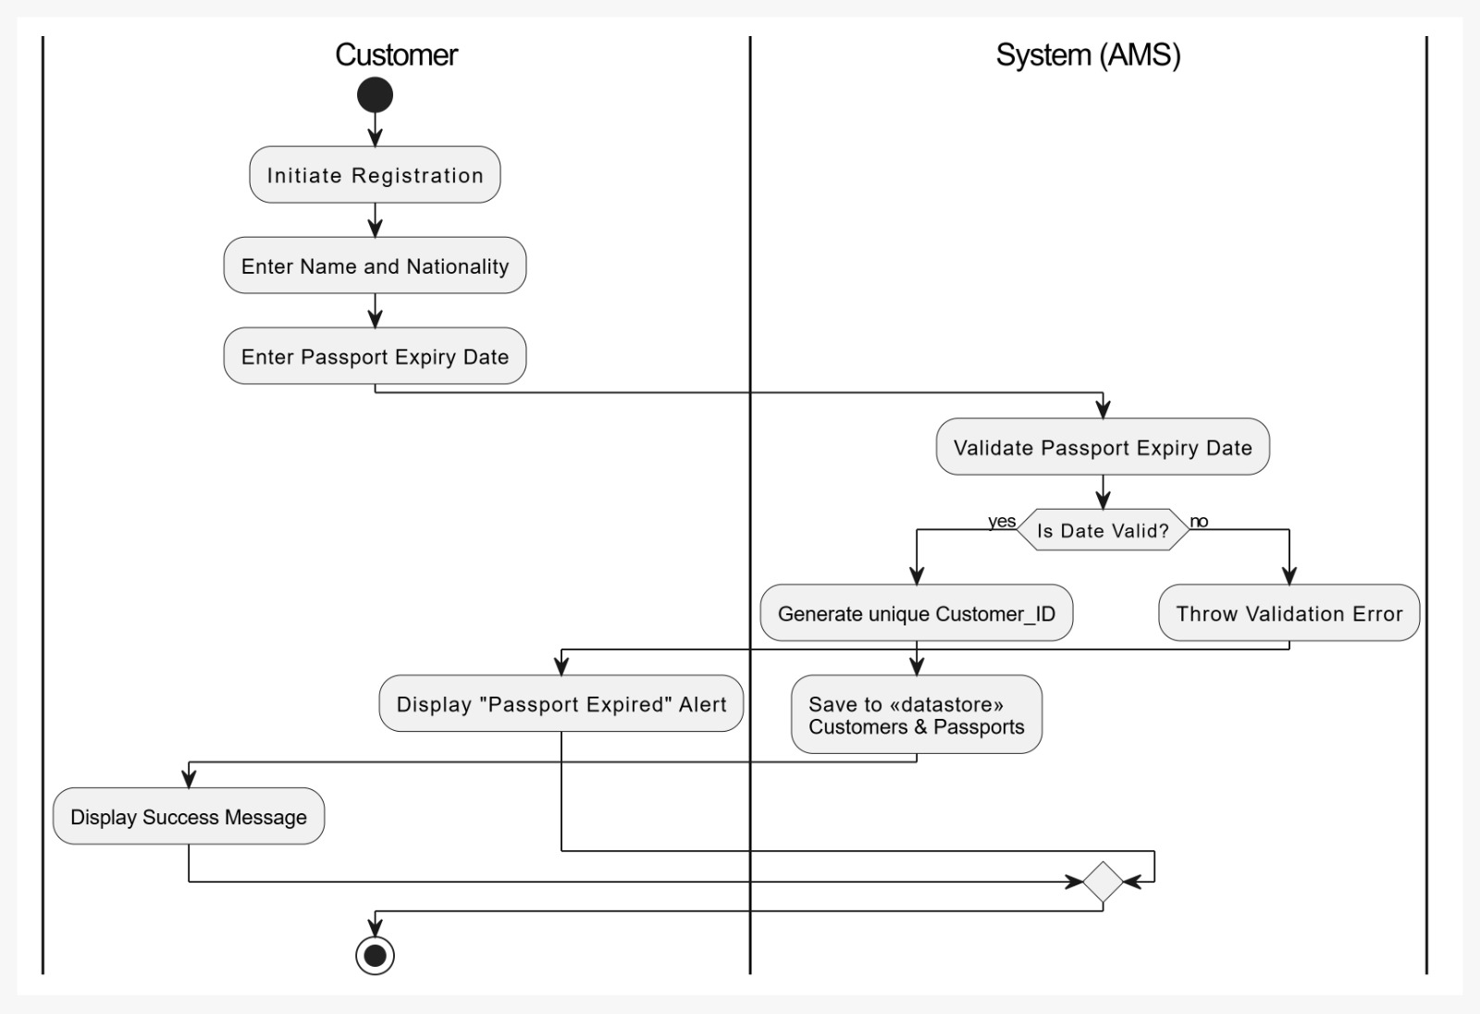

Admin can check customer records
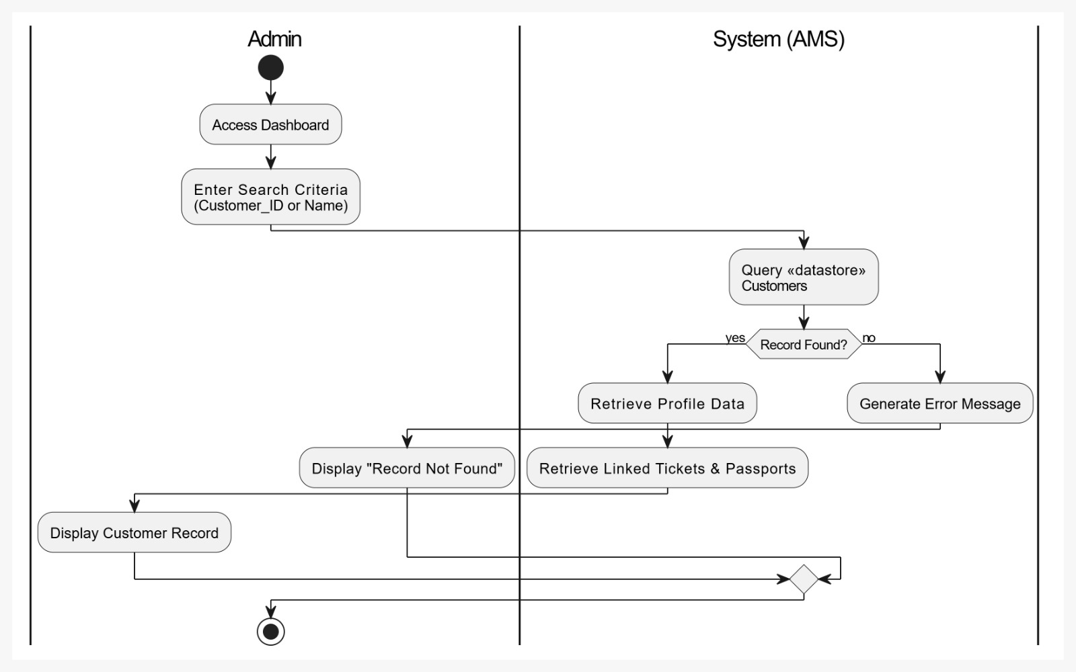

Admin can add flights, airlines etc.
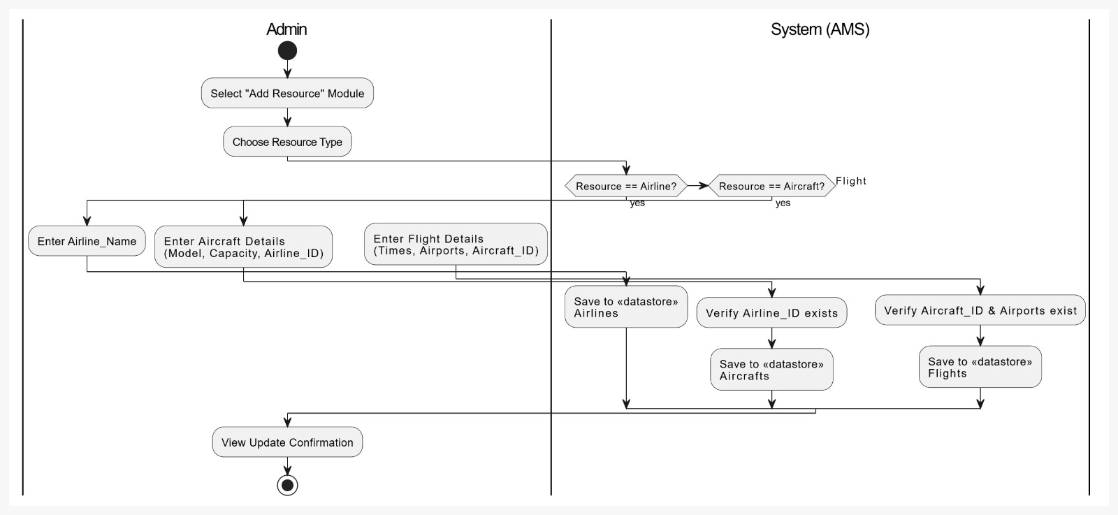

Customer can book available flights
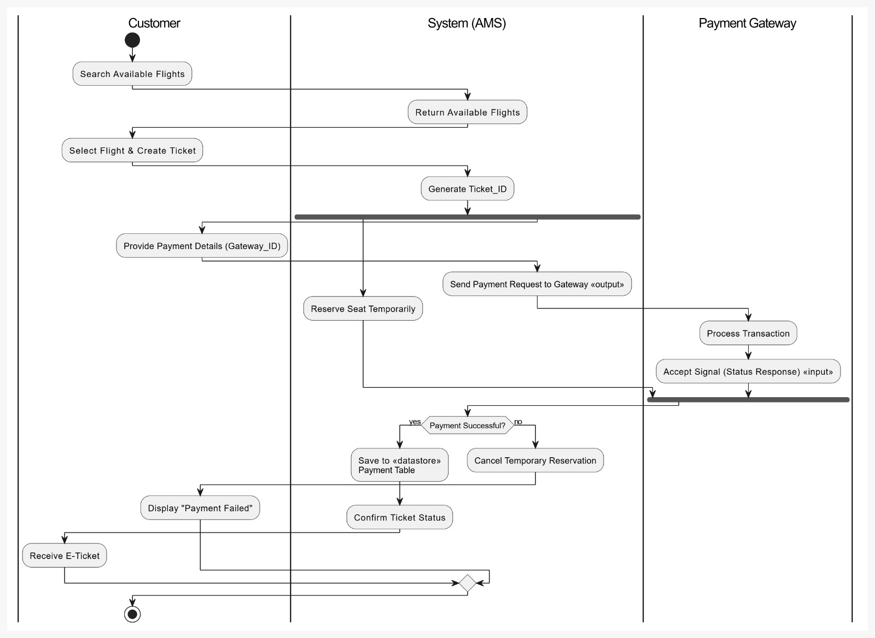

Customer can add baggage
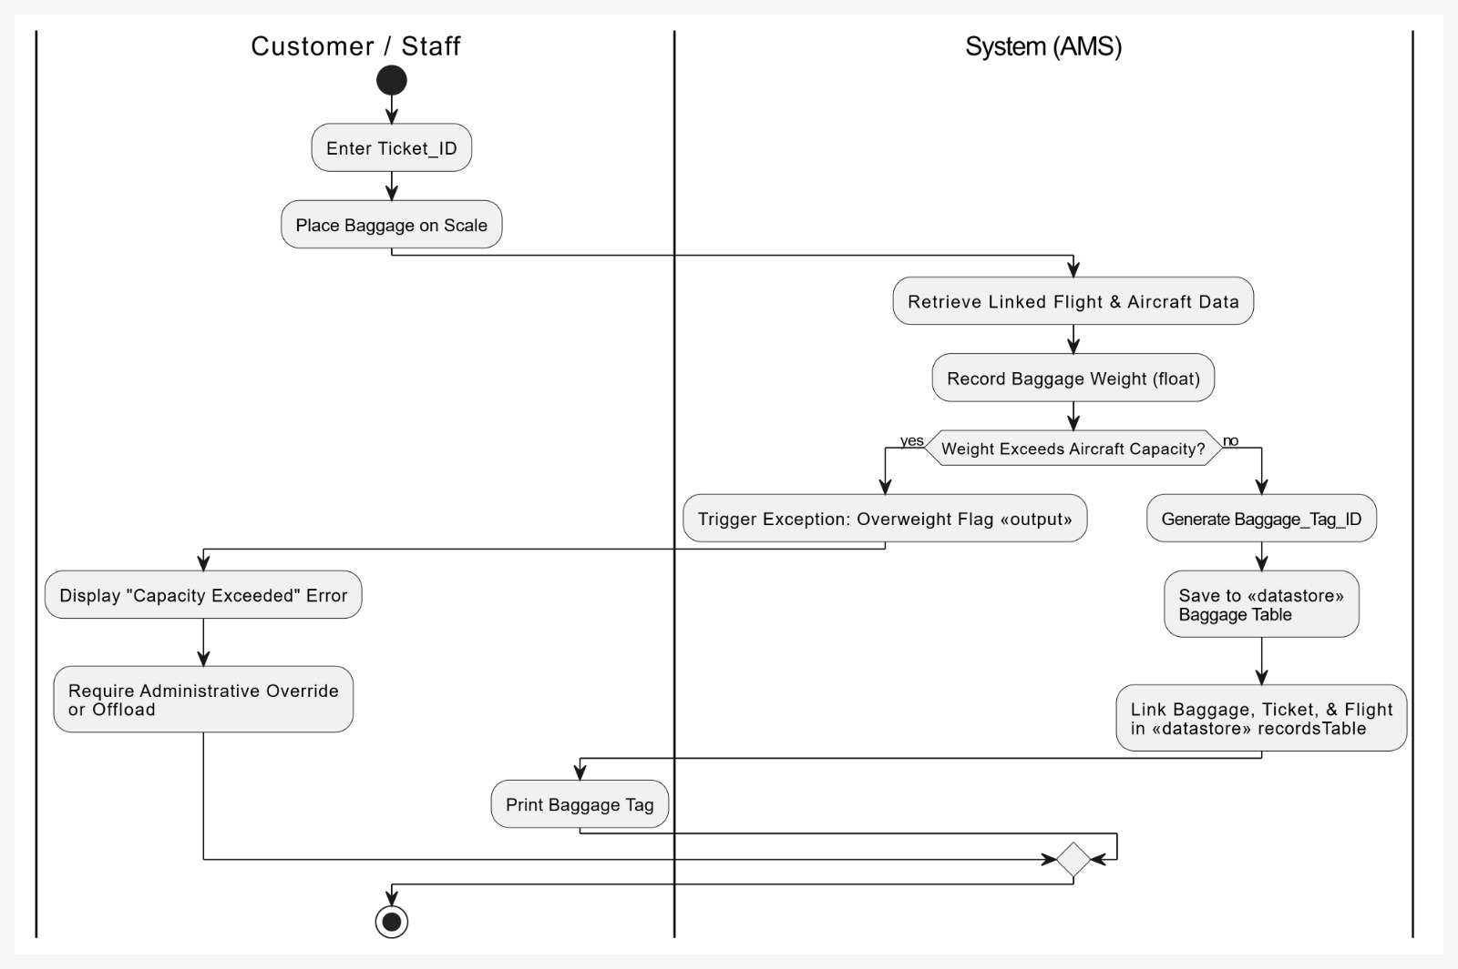

5.2.3 State Diagram
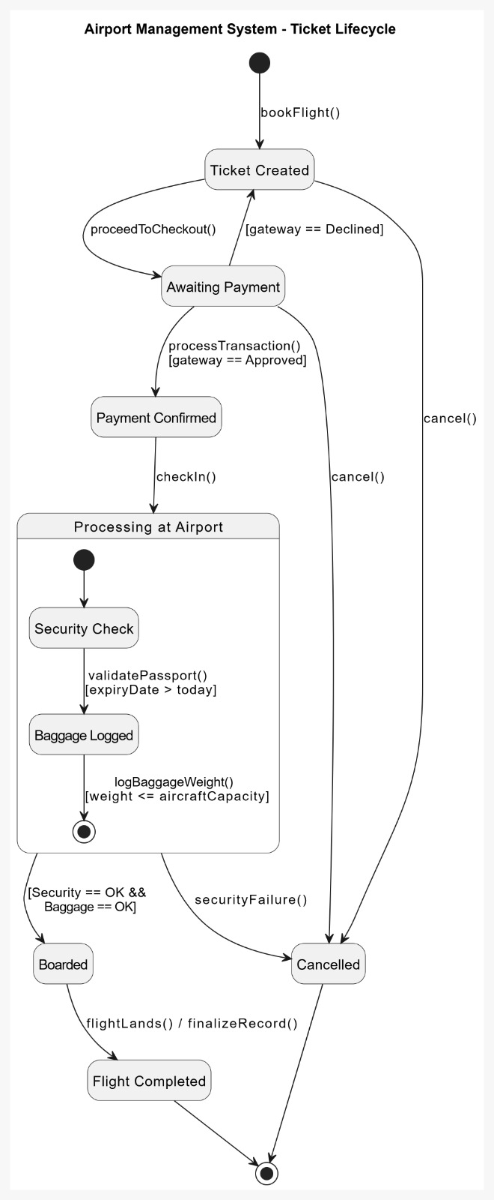

Class Diagram
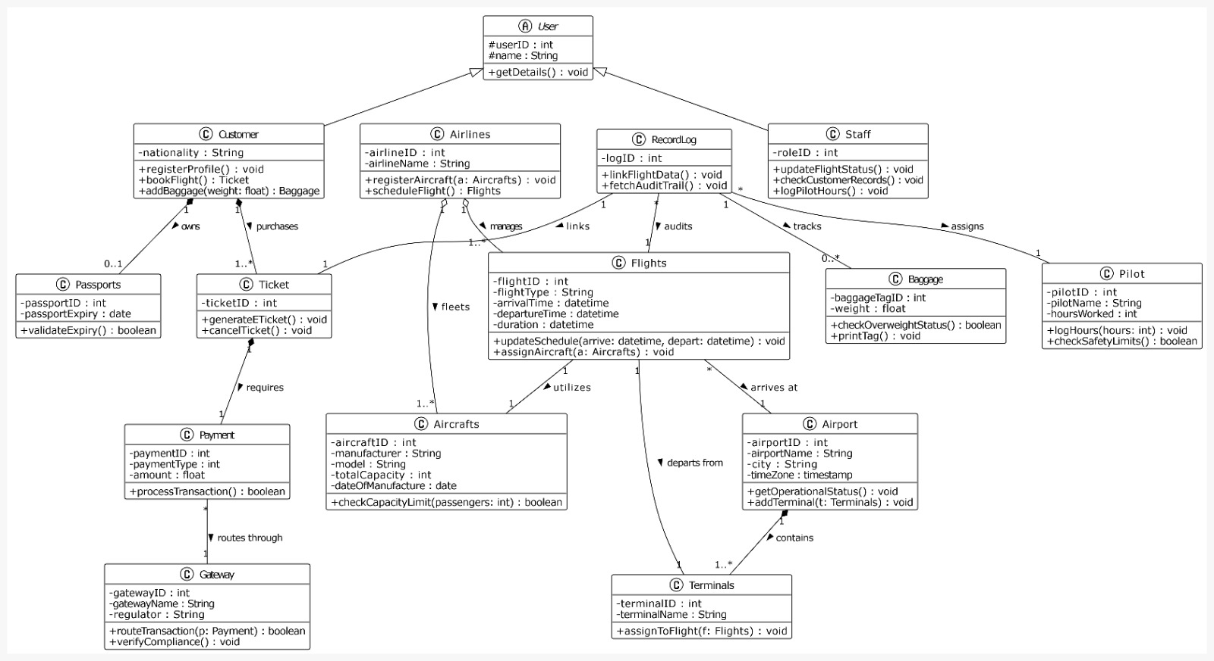

Collaboration Diagram
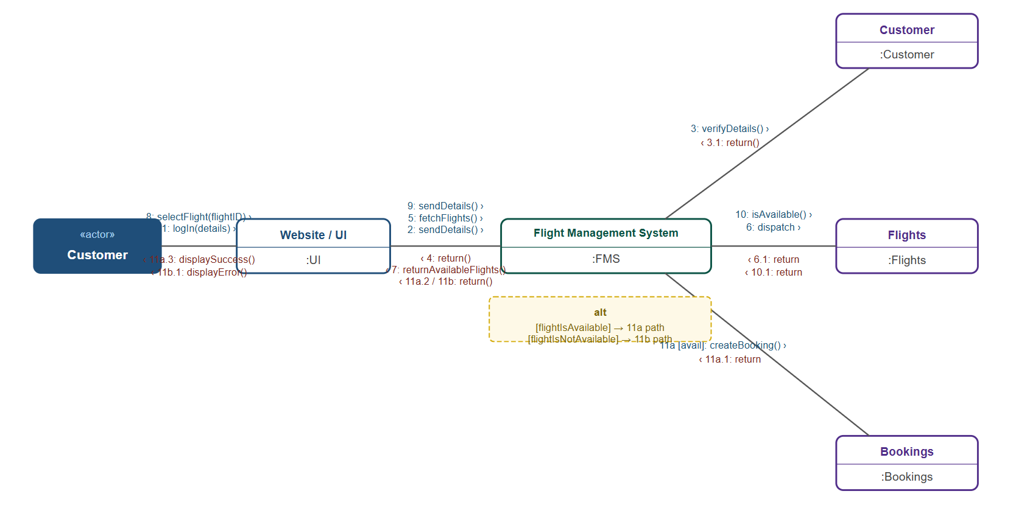
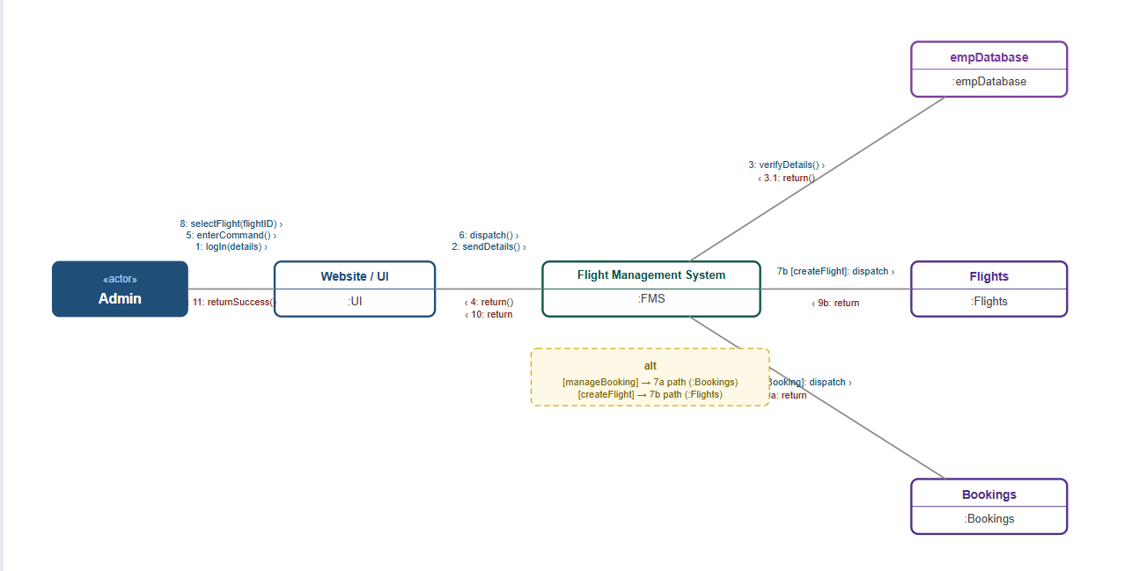

References
Not Applicable.

Appendices
Not applicable.

